**PROJECT REPORT**

**ON**

**NEW MARVEL COLLEGE**

**SNEHA YARLAGADDA**

**PRASHANTH EDIGE**

**MADHAN ENDETI**

**HARSH PATHANIA**

**Under the Guidance of**

**TONI WAGONNER**

**Professor**



**DEPARTMENT OF COMPUTER SCIENCE**

**UNIVERSITY OF ILLINOIS SPRINGFIELD**

**ACKNOWLEDGEMENT**

It plunges us in exhilaration in taking privilege in expressing our heartfelt Gratitude to all those who helped, encouraged and supported us in the successful completion of our project.

We render our graduate to respected Toni Waggoner, Our project guide, for her initiative in creating a conductive atmosphere in which we could complete the coursework and project work successfully.

- Sneha Yarlagadda

- Prashanth Edige

- Madhan Endeti

- Harsh Pathania

**INDEX**

|  |  |  |
| --- | --- | --- |
| NO | TITLE | PAGE NO |
| 1 | INTRODUCTION | 4 |
| 2 | EXISTING SYSTEM | 5 |
| 3 | PROPOSED SYSTEM | 6 |
| 4 | REQUIREMENTS | 7 |
| 5 | CONCEPTUAL VIEW | 8 |
| 6 | MODIFIED CONCEPTUAL VIEW | 9 |
| 7 | DATA STRUCTURE DIAGRAM | 10 |
| 8 | SQL QUERIES | 11-12 |
| 9 | SCREEN SHOTS | 13-21 |

**INTRODUCTION**

* In the current world of innovation, PCs are influencing our lives in more ways than we most likely know about. COMPUTERIZED MANAGEMENT, keeping up data of an instructive organizations, Schools, other the rundown is endless.
* This project indicated all working that taken by a College Supervisor …
* On the off chance that supervisor need essential data he checks the data around a student, staff and so on.
* It is hard to set up the manual work to store the data about the all students and faculty. So this project stores those kind of data utilizing computerized system.
* This project is about NEW MARVEL COLLEGE. They require a database system to store information regarding students, faculty, courses and so on.
* The report contains Database design methodology and the data structure diagram with SQL implementation for creation of tables and insertion of data.
* Students, faculty, courses details are maintained in forms and reports.
* Certain functionality also had to be abandoned to meet time constraints. The application is not designed to replace the existing Software but to complete the future needs and requirements of organization.

# **EXISTING SYSTEM**

Whenever we implement new system it is developed to remove the shortcomings of an existing system. The existing system is based on manual system. It has the following disadvantages:

* **Wastage of time:**As the test is conducted manually it takes lot of time to attempt question of that particular test***.***
* **Inaccuracy:**While conducting the test papers manually it can happen that questions papers are not printed properly, in accuracy can also take place while checking the answer sheets and the teachers may mistake while calculating marks. All the above leads to the problem of inaccuracy.
* **Late declaration of result:** In the existing system answer sheets are checked manually so it takes a lot of time while checking the answer sheets. So the result is declared late.
* **Wastage of money:**While checking the different answer sheets different professor is hired. So it requires a lot of money against the checking of answer sheets.
* **Chances of Partiality:** In the existing system there are chances of partiality while checking the answer sheet of particular student. This is because some professor may be biased towards some student. So there are chances of partiality. Due to all the above problem of manual system the new computerized system is developed.

**PROPOSED SYSTEM**

We have developed new system, which is based on computer in which the student used to give test on the computer by simply clicking the answers. It is most reliable & time saving system while conducting some entrances test.

* **Time Saving:** As the test is conducted on computer it takes very less time for the student to attempt the question by simply clicking on the answer which they think to be right.
* **Accuracy**: Unlike the manual system there is no in accuracy while checking the answer of a question. Since it does not make any calculation mistake while at the same time of checking.
* **Quick Declaration of Result:** In the computerized system the results are declared in less time i.e. within the fraction of minutes. So we can say that in computer system are more efficient than the existing system from the point of view of declaring the result
* **Money Saving**: Unlike the existing the computerized system does not require the any professor to check the answer sheet so this saves the lot of money.
* **Reduces The Chances Of Partiality:** As the answer s is checked by the computer itself so there are no chances of partiality while checking the answers.

**REQUIREMENTS**

**HARDWARES REQUIRED:**

1. Processor: INTEL CELERON DUAL CORE / CORE2DUO.
2. Primary Memory (RAM): Min.256 MB
3. Secondary Memory: Hard Disk
4. Printer

**SOFTWARES REQUIRED:**

1. Microsoft Access 2013

**CONCEPTUAL VIEW**

Sales_Rep (Sales_No, Sales_Name, Sales_Street, Sales_City, Sales_State, Sales_Zip, Sales_PhNo, Sales_TotalCommission, Sales_CommissionRate)

SK Sales_Name

Customer (Cust_No, Cust_Name, Cust_street, Cust_City, Cust_State, Cust_zip, Cust_Phno, Cust_ContactPerson, Cust_CurrentBalance, Cust_CreditLimit, Sales_No)

FK Sales_No -> Sales_Rep

SK Cust_Name

Product(Prod_No, Manu_No, Manu_Name, Prod_desc, Model_No, Price, NoOfUnitsAvailable, OnHand_Value, Class_No )

FK Class_No ->Product_Classification

Warehouse(Ware_No,Ware_desc,Prod_No)

FK Prod_No ->Product

Product_Classification (Class_No,Class_desc)

Order(Order_No, Order_Date, Cust_No, Prod_No, NoOfUnits_Ordered, QuotedPrice)

FK Cust_No -> Customer

FK Prod_No ->Product

**No Special restrictions in DBDL.**

**MODIFIED CONCEPTUAL VIEW**

Department (Dnum, DeptName)

Faculty (Facnum, Facname, Dnum)

FK Dnum -> Department

SK Facname

Student (Stunum, Stuname, Advnum, GPA, HScode)

FK Advnum -> Faculty(Facnum)

FK HScode -> HighSchool

SK Stuname

StuDept (Stunum, Dnum, Capacity)

FK Stunum -> Student

FK Dnum -> Department

Course (Coursenum, Cdescrip, Numcred)

FacCourse (Facnum, Coursenum)

FK Facnum -> Faculty

FK Coursenum -> Course

StuCourse (Stunum, Coursenum, Grade)

FK Stunum -> Student

FK Coursenum -> Course

HighSchool (HScode, HSname)

SK HSname

**SPECIAL RESTRICTION:**

Grade must be one of the values (A, B, C, D, or F)

**DATA STRUCTURE DIAGRAM**

Faculty

StuDept

FacCourse

Student

Department

Course

HighSchool

StuCourse

**SQL QUERIES**

**Creating Tables:**

* **Department table**

CREATE TABLE DEPARTMENTS ( Dept_No INT NOT NULL,Dept_Name VARCHAR NOT NULL,PRIMARY KEY(Dept_No));

* **Faculty table**

CREATE TABLE FACULTY (Fac_No INT NOT NULL,Fac_Name VARCHAR NOT NULL, Dept_No INT NOT NULL,PRIMARY KEY (Fac_No),FOREIGN KEY (Dept_No) REFERENCES DEPARTMENTS (Dept_No));

* **High School table**

CREATE TABLE HIGH_SCHOOL (HS_Code INT NOT NULL,HS_Name VARCHAR NOT NULL,PRIMARY KEY(HS_Code));

* **Student table**

CREATE TABLE STUDENT (Stu_No INT NOT NULL,Stu_Name VARCHAR NOT NULL,Adv_No INT NOT NULL,GPA INT,HS_Code INT NOT NULL,PRIMARY KEY (Stu_No),FOREIGN KEY (Adv_No) REFERENCES FACULTY (Fac_No),FOREIGN KEY (HS_Code) REFERENCES HIGH_SCHOOL (HS_Code));

* **Student Department table**

CREATE TABLE STUDENT_DEPARTMENT (Stu_No INT NOT NULL,Dept_No INT NOT NULL,Capacity INT,PRIMARY KEY (Stu_No,Dept_No),FOREIGN KEY (Stu_No) REFERENCES STUDENT (Stu_No),FOREIGN KEY (Dept_No) REFERENCES DEPARTMENTS (Dept_No));

* **Course table**

CREATE TABLE COURSE (Course_No INT NOT NULL,Course_Desc VARCHAR NOT NULL,Course_Cred INT,PRIMARY KEY (Course_No));

* **Faculty Course table**

CREATE TABLE FACULTY_COURSE (Fac_No INT NOT NULL,Course_No INT NOT NULL,PRIMARY KEY (Fac_No,Course_No), FOREIGN KEY (Fac_No) REFERENCES FACULTY (Fac_No),FOREIGN KEY (Course_No) REFERENCES COURSE (Course_No));

* **Student Course table**

CREATE TABLE STUDENT_COURSE(Stu_No INT NOT NULL,Course_No INT NOT NULL,Grade VARCHAR NOT NULL,PRIMARY KEY (Stu_No,Course_No), FOREIGN KEY (Stu_No) REFERENCES STUDENT (Stu_No), FOREIGN KEY (Course_No) REFERENCES COURSE (Course_No));

**SCREENSHOTS**

* **Inserted Data**

Department table:

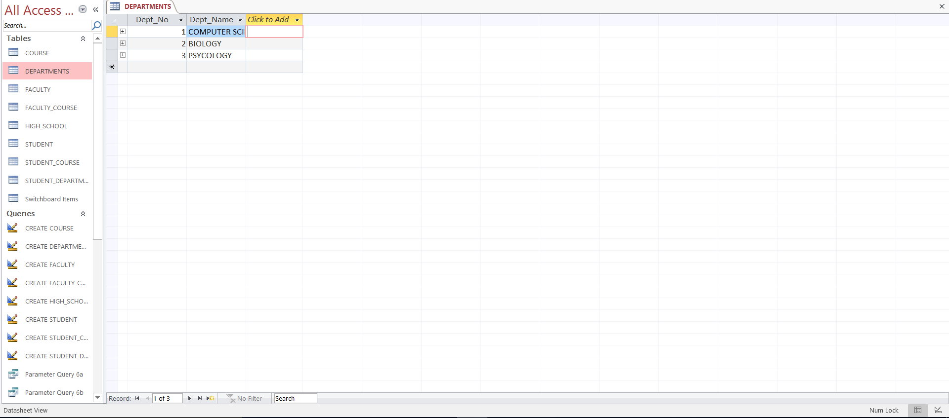

Faculty table:

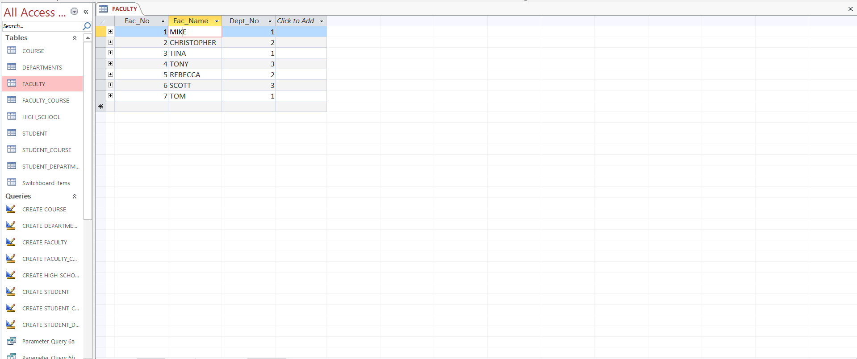

High School Table:

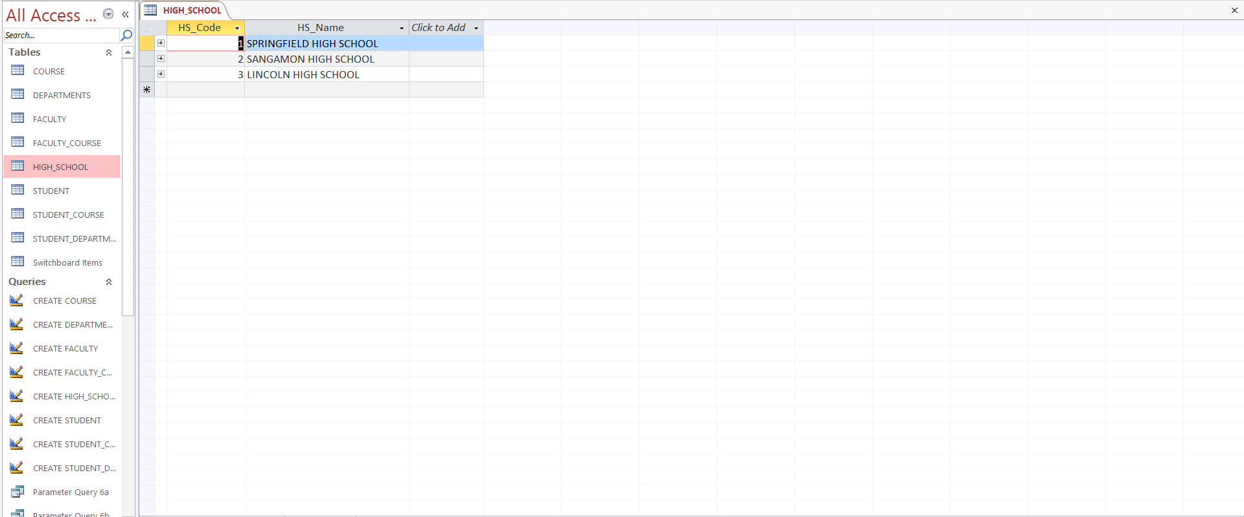

Student table:

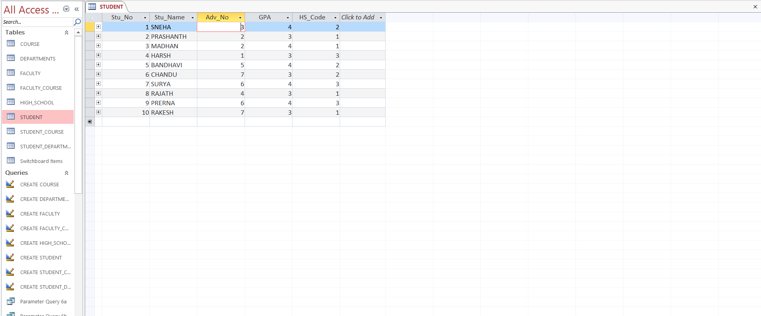

Student Department table:

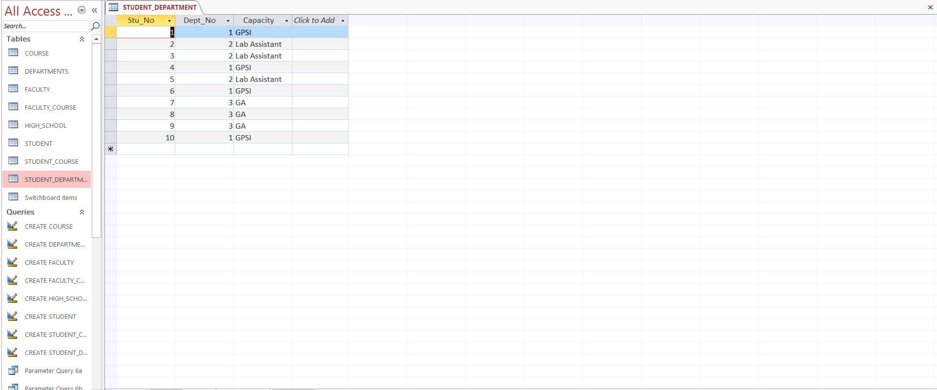

Course Table:

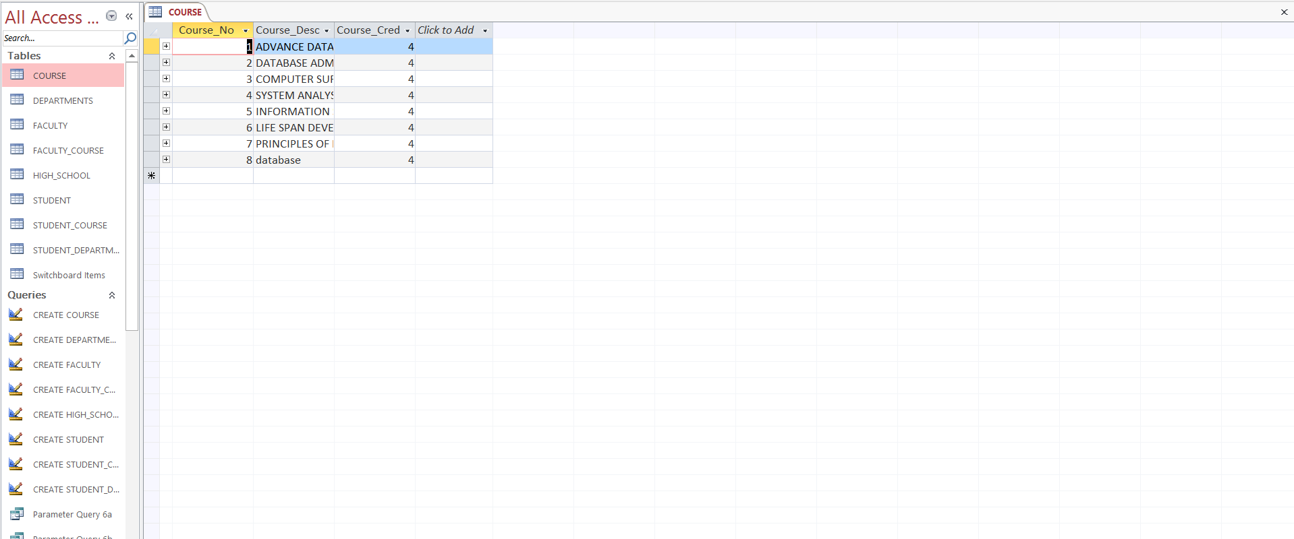

Faculty Course Table:

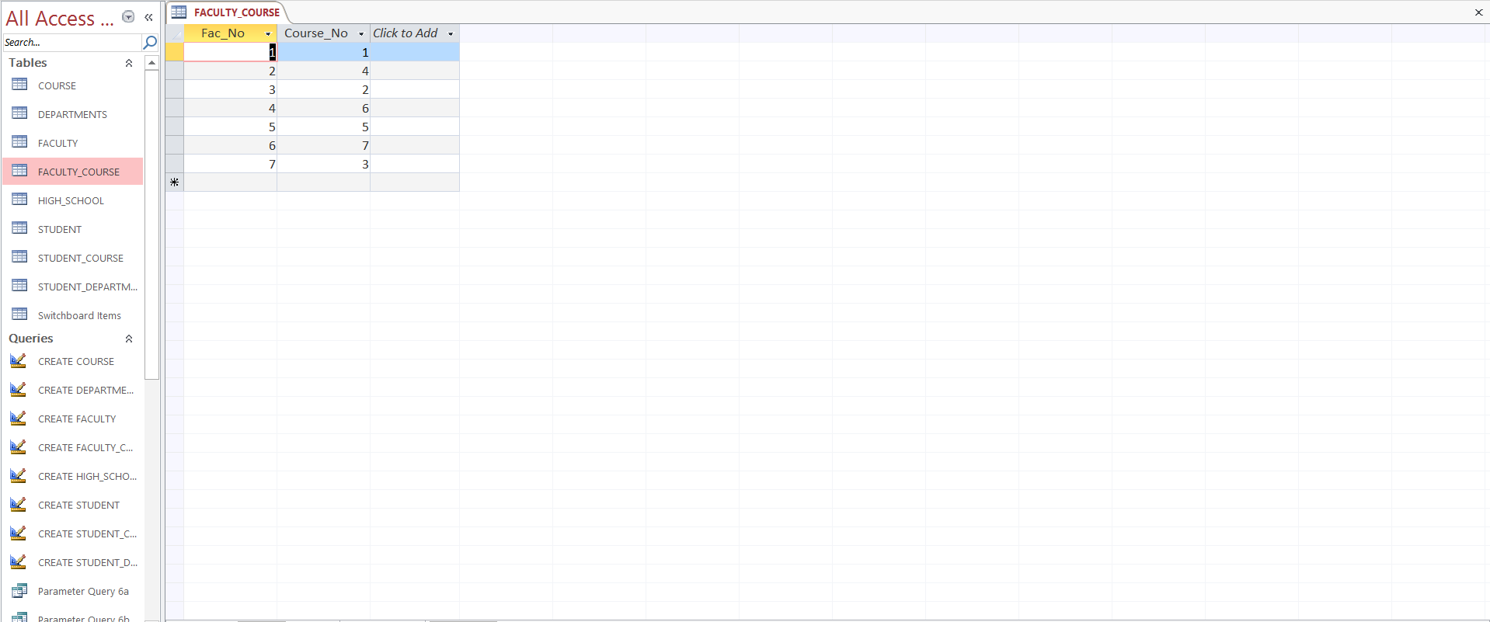

Student Course Table:

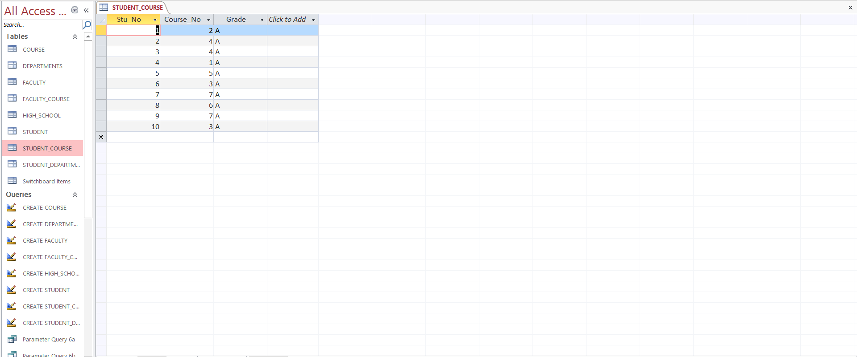

* Switchboard

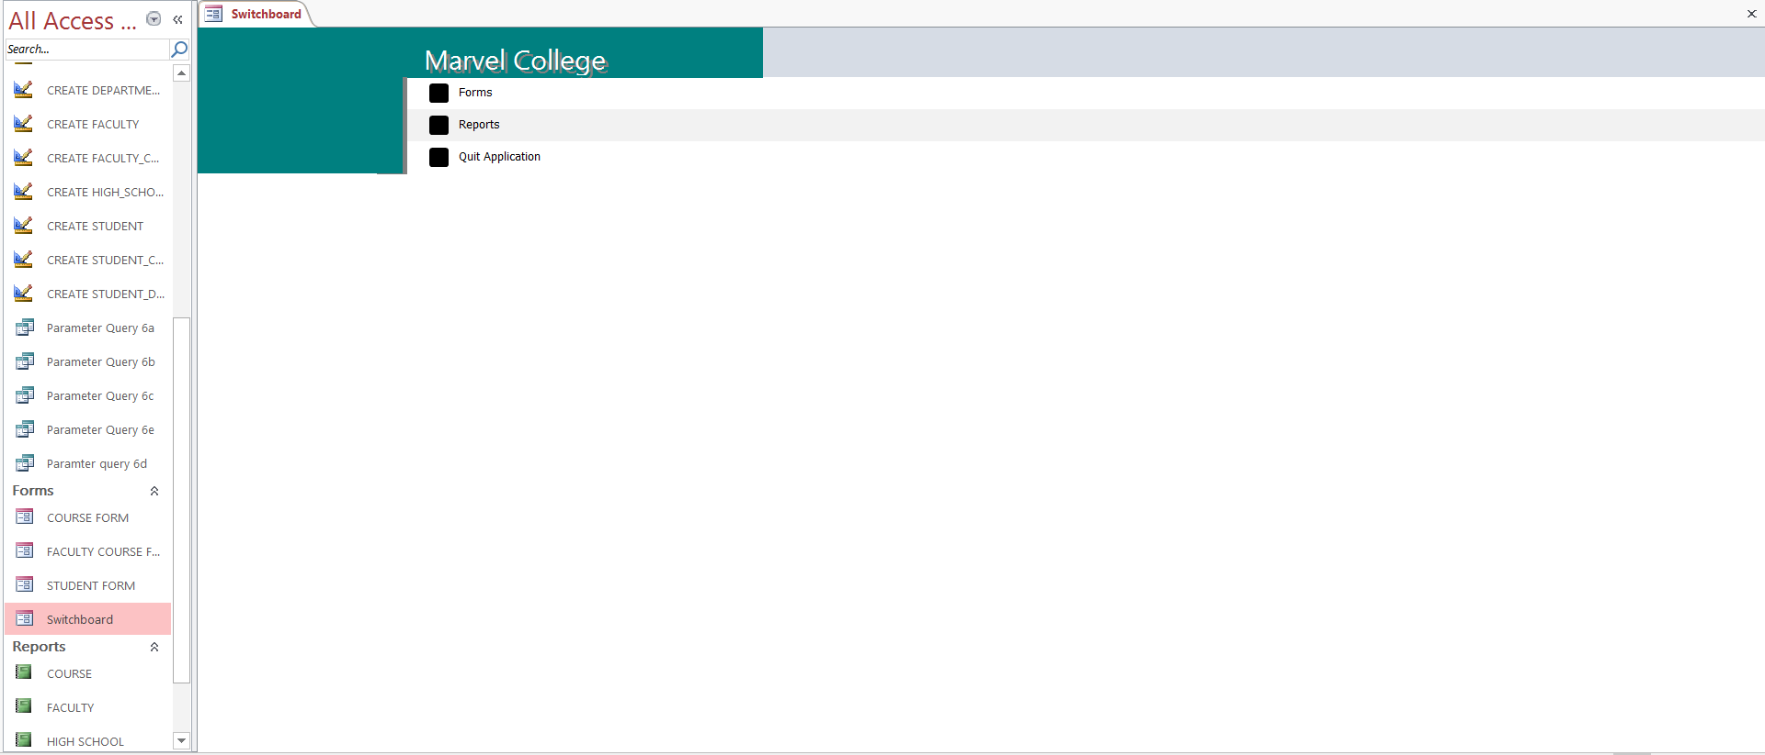

* Forms

Login Form

Course Form

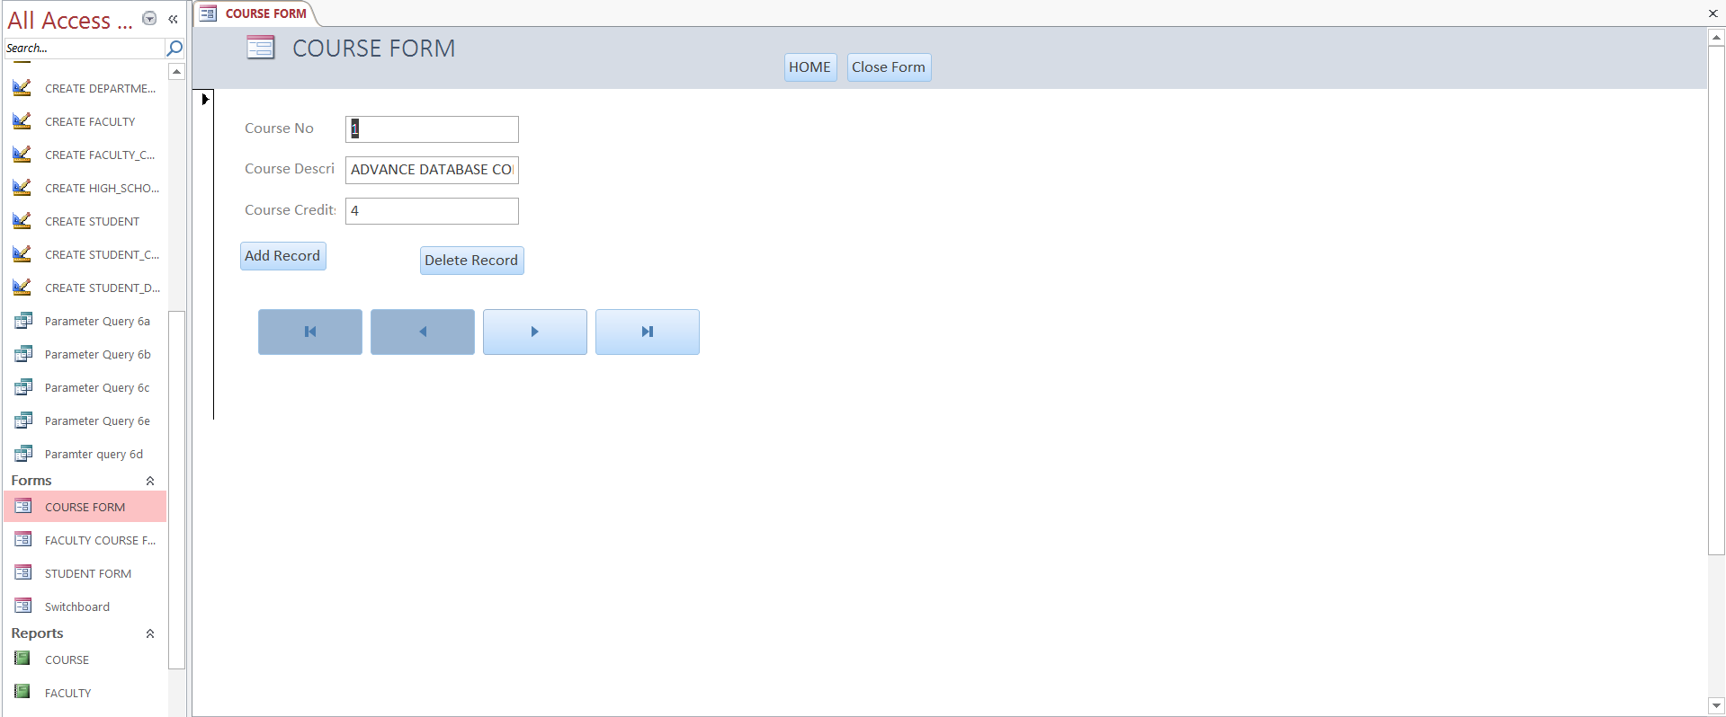

Faculty Course Form

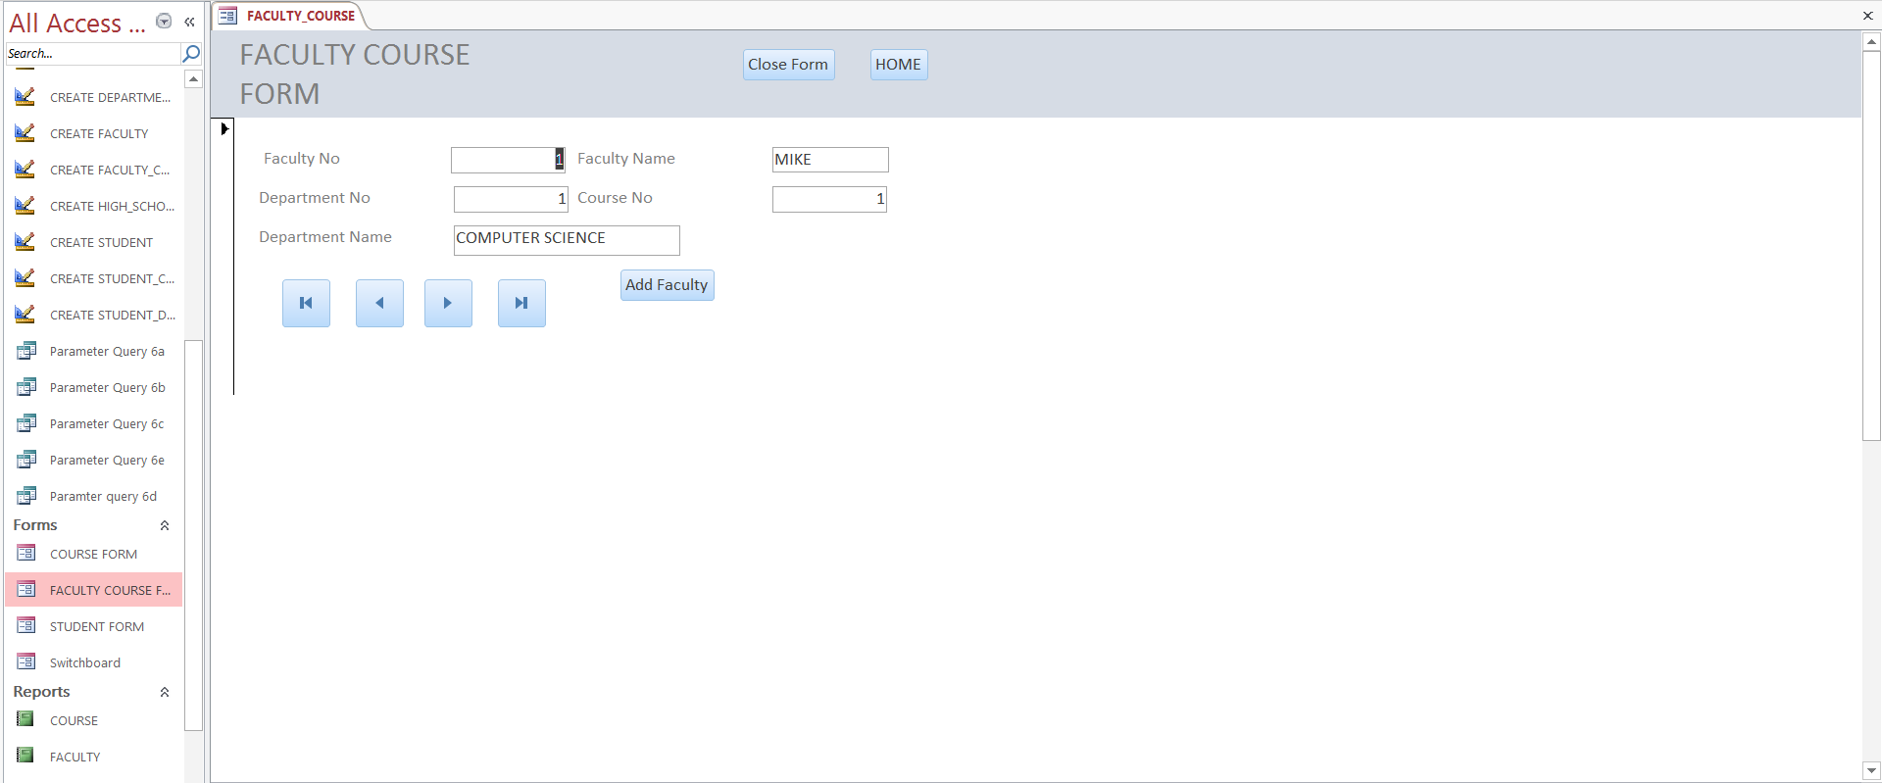

Student Form

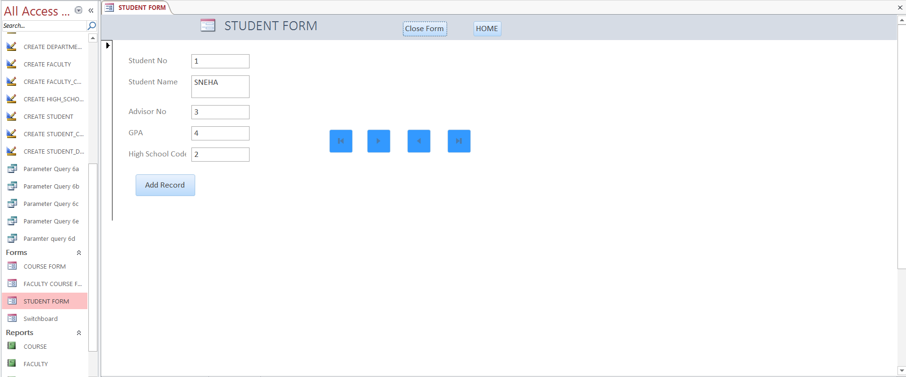

* Reports

Course Report

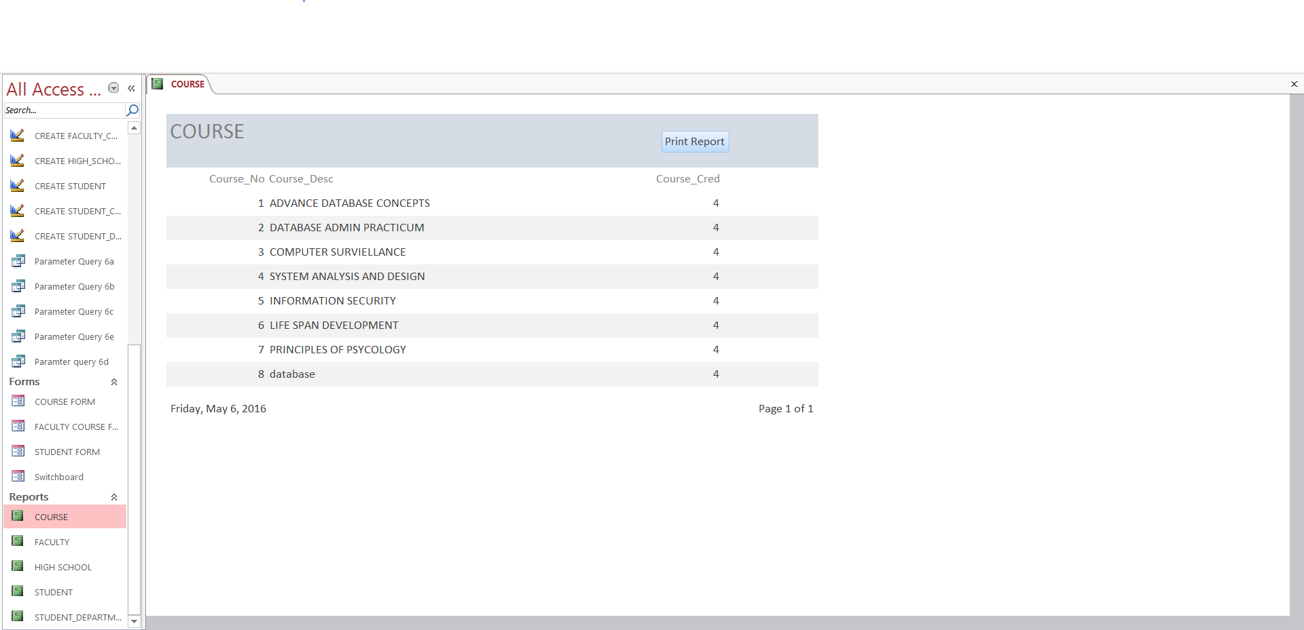

Faculty Report

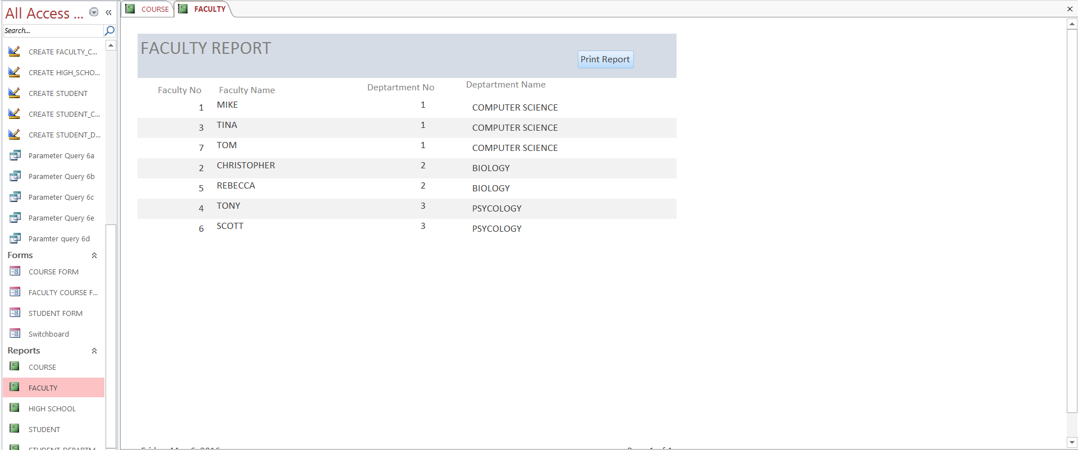

Manufacturer Report

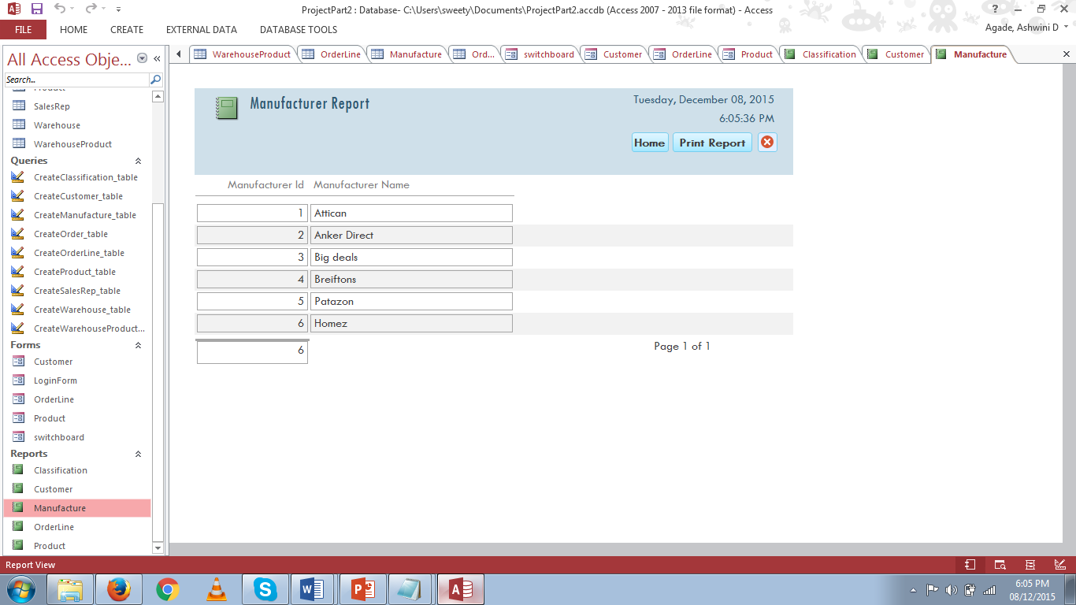

High School Report

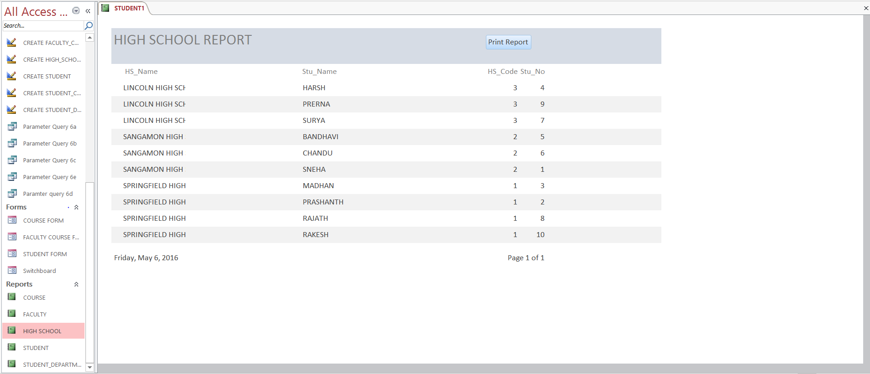

Student Report

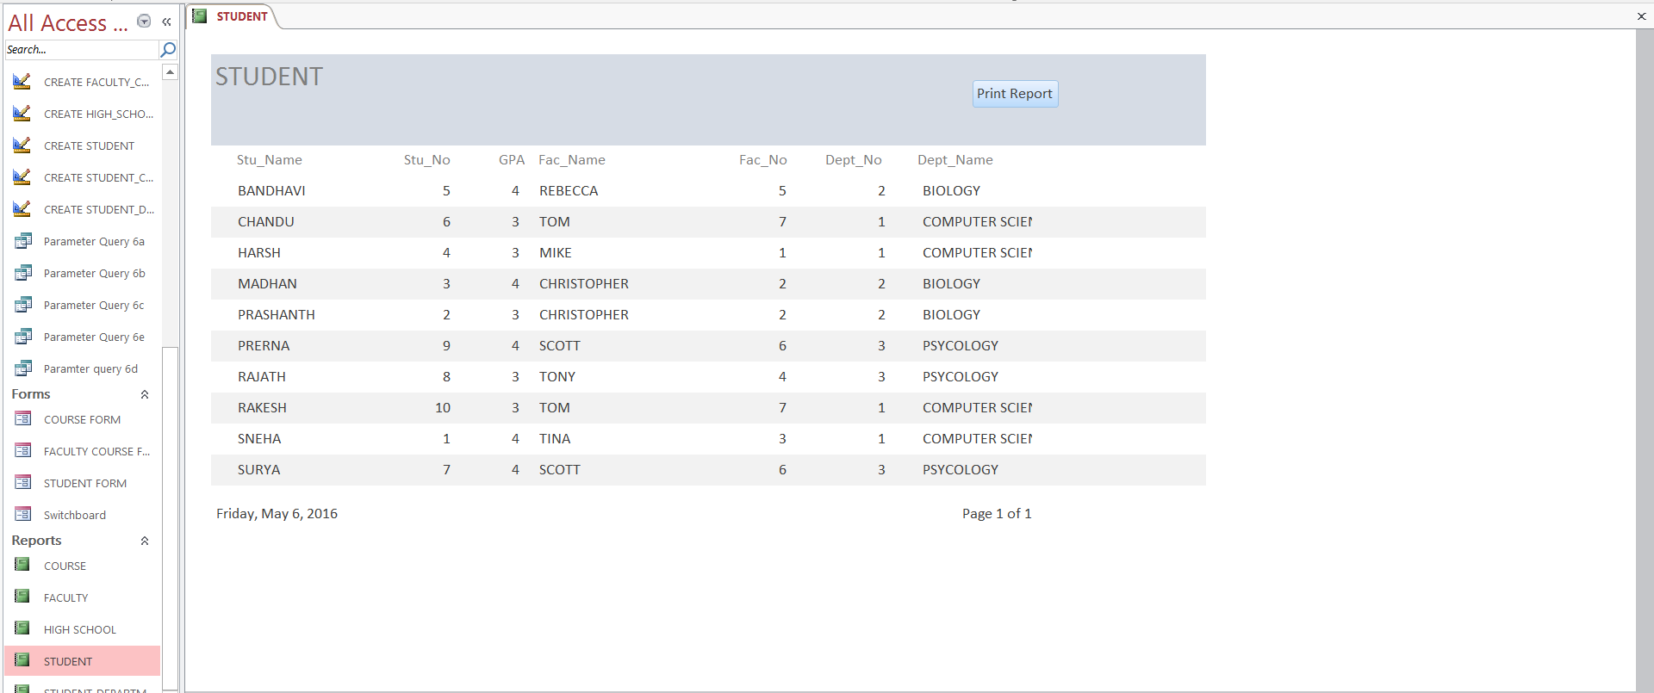

Student Department Report

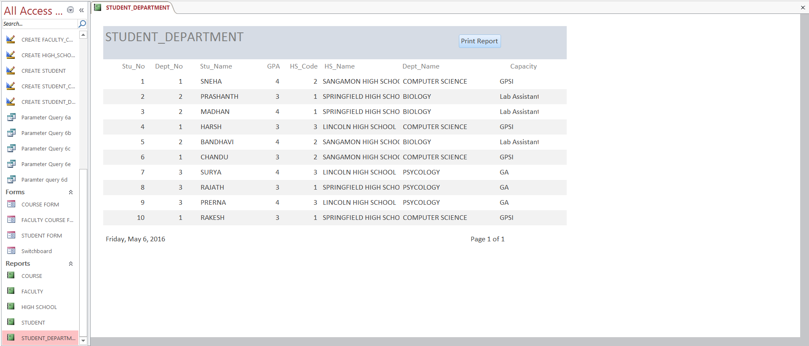

**GROUP LOG**

|  |  |  |  |
| --- | --- | --- | --- |
| DATE | WORKED ON | TIME TAKEN | TOTAL HOURS |
| 10-30-2015 to 11-02-2015 | Creation of tables | 10-30-2015  Creation of classification table (12:00 to 12:30pm)  Creation of product table (12:30 to 1:00 pm)  Creation of customer table (1:00 to 1:30 pm)  11-01-2015  Creation of sales representative table (1:00 to 1:30 pm)  Creation of warehouse table (1:30 to 2:00 pm)  Creation of manufacturer table (2:00 to 2:30 pm)  11-02-2015  Creation of warehouseproduct table (4:00 to 4:30 pm)  Creation of order table (4:30 to 5:00 pm)  Creation of orderline table (5:00 to 5:30 pm) | 4.30 Hrs |
| 11-04-2015 to 11-06-2015 | Inserting values into tables | 11-04-2015  Insertion of values into classification table(12:00 to 12:30pm)  Insertion of values into product table(1:00 to 1:30 pm)  Insertion of values into customer table  (1:30 to 2:00 pm)  11-05-2015  Insertion of values into sales representative table  (4:00 to 4:30 pm)  Insertion of values into warehouse table  (4:30 to 5:00 pm)  Insertion of values into manufacturer table  (5:00 to 5:30 pm)  11-06-2015  Insertion of values into warehouseproduct  (11:00 to 11:30 am)  Insertion of values into order table  (11:30 to 12:00 pm)  Insertion of values into orderline table  (12:00 to 12:00 pm) | 4.30 Hrs |
| 11-09-2015 to 11-15-2015 | Forms | 11-09-2015  Creation of customer form(12:00 to 1:00 pm)  11-11-2015  Creation of product form  (1:00 to 2:00 pm)  11-13-2015  Creation of order form  (12:00 to 1:00 pm) | 3 Hrs |
| 11-16-2015 to 11-20-2015 | Reports | 11-16-2015  Report creation for classification(11:00 to 11:20 am)  Report creation for customer(11:20 to 11:40 am)  Report creation form manufacturer(11:40 to12:00 pm)  11-18-2015  Report creation for order(1:00 to 1:20 pm)  Report creation for product(1:20 to 1:40 pm) | 1.20 Hrs |
| 11-22-2015 to 11-24-2015 | Switch Boards and data security implementation | 11-22-2015  Switch boards(12:00 to 3:00 pm)  11-24-2015  Login form(1:00 to 3:00 pm) | 5 Hrs |
| 11-26-2015 to 12-02-2015 | Testing | 11-26-2015  Creation, Insertion, Forms  (1:00 to 3:00 pm)  12-02-2015  Reports, Switch boards, Login Form(12:00 to 2:00 pm) | 4 Hrs |
| 12-04-2015 to 12-08-  2015 | Power point Presentation(PPT), Documentation | 12-04-2015  Documentation(4:00 to 6:00 pm)  12-06-2015  Documentation(3:00 to 6:00 pm)  12-08-2015  Power Point Presentation(1:00 to 2:00 pm) | 6 Hrs |